# Testing work （Phase 8）

## Test Environment

The detailed hardware configurations of all servers are described as follow:

|  |  |  |  |  |  |  |
| --- | --- | --- | --- | --- | --- | --- |
| **Computer name** | **CPU** | **Memory** | **HD** | **OS** | **Other** | **Comments** |
| PS Server Panda upgrade | Interl(R) Xeon® CPU E5-2350 @ 1.80 \* 6 | 12GB | 1TB | Windows 2008 R2 64bit | SQL server workgroup 2008 | Use the network 100Mbps |
| Workstation Server | Intel i3-2120 3.3GHz | 2GB | 80GB | Windows 7 SP1 64bit | QTP 11 | 6 virtual machine in server |
| Terminal | Intel Atom D525 1.8GHz | 4GB | 450GB | Windows Embedded Standard SP1 64bit | UTF 12.0 trail |  |
| Cloud Film Server | Huawei Cloud 3 4CORE | 8G | 40GB +  200GB | Windows Server 2016 |  |  |
| Cloud film DB Server | Huawei Cloud 3 2CORE | 8G | 40GB | Huaiwei cloud offer | MySQL 5.7 |  |

Table 1 Hardware Configuration

## Test scenario and strategy

Virtual User: 21 Users

Duration: 8 hour

Description: Use the test tool simulates the patient operations. Monitor the server software and hardware resource usage. The detail information as follow:

1. Use automation tool simulate the doctor print film work. Simulate 6 GX Platform by using QTP and WinDPSTester tool. Each client prints one film which size is 20MB every 60 seconds.
2. Use LR tool simulate 8 K2/K3 terminals to print film. Each client prints one film which size is 10MB random 5 to 10 seconds.
3. Use LR tool simulate 8 users to do report archive operations. Each client archive report in random 5 to 10 seconds and size is random with 100kb and 4Mb.
4. Use LR tool simulate 8 terminals to print paper reports. Each client prints report random 5 to 10 seconds.
5. The OCR setting is not has rule for GX platforms in step1 and other setting are set as default. The OCR service will under the strong stress without configure the rule.
6. Simulate 5 users to do the query information, view monitor page, query reconciliation films and report, expand the record, change the status, set holding time and other operations in worklist.
7. Monitor the transaction response time.
8. Monitor the hardware resource usage on PS.
9. Monitor the resource usage for database on PS.
10. Start/Stop 1 virtual user every 5 seconds and run the scenario for 8 hours.
11. Use the business Upload network bandwidth to 100M.

Note:

We will do the performance testing work under big stress for system. If system can work well under current stress and the transaction process ability meets the requirement, we will give the conclusion the system performance is pass.

## Test Tool

Load Runner 12.

## Database setting

Memory: Set the min and max memory size to 4GB.

Index fill factor: 80.

File: Increase the data and log files size and the rule is increase 500Mb as fixed size.

## IIS setting

Connection: Set the max connection value to 4000 and keep other setting as default.

## Test Object version

KIOSK cloud film 3.0.3.0 B26P01 + CloudUploadService Patch + new Upload Design

## Background data

We prepared a background records in the PS system. The data size is calculated by the typical site which printed 3,000 films in a workday. That means the records of films in db should more than 972,000 (3000records / day \*54 weeks \* 6 workday). QA team had prepared these data with SQL script and automation script. These data can backup and import by DB tool.

The detail data records in DB as follow:

|  |  |
| --- | --- |
| **Table Name** | **Data Volume (records)** |
| printer.dbo.DeliveryJob | 995199 |
| printer.dbo.ImageBox | 3530116 |
| printer.dbo.Page | 314893 |
| printer.dbo.Session | 571212 |
| wggc.dbo.Patient | 1224710 |
| wggc.dbo.Study | 1434574 |
| wggc.dbo.AFP\_PrintTerminalInfo | 70 |
| wggc.dbo.Series | 1434524 |
| wggc.dbo.Image | 1434527 |
| wggc.dbo.AFP\_FilmInfo | 1420905 |
| wggc.dbo.AFP\_ReportInfo | 1232003 |
| wggc.dbo.AFP\_ExamInfo | 2308723 |
| wggc.dbo.AFP\_PrintTask | 4324918 |
| wggc.dbo.T\_Integration\_ExamInfo | 1421769 |
| AFP\_PrintMode | 523684 |
| wggc.dbo.vi\_KIOSK\_ExamInfo\_Order | 838208 |

## Test Error

There are 21 errors existed in the testing work s.

|  |  |  |
| --- | --- | --- |
|  |  |  |
|  |  |  |
|  |  |  |
|  |  |  |
|  |  |  |
|  |  |  |
|  |  |  |
|  |  |  |

Error analyzes:

## Test result of PS server

### Test result of PS transactions

After the performance testing works, the transactions result of PS print module as follow:

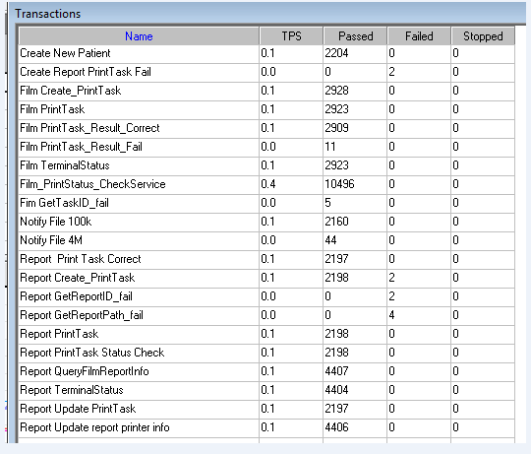

### Test Statistic Report of PS

|  |  |
| --- | --- |
| Analysis Summary | Period: 2018/9/6 19:15 - 2018/9/7 3:18 |

|  |  |
| --- | --- |
| **Scenario Name:** | E:\ECS\Performance\Script\208\ScenarioPUMA\_Reliability\_171.lrs |
| **Results in Session:** | c:\Users\Administrator\AppData\Local\Temp\res193\res193.lrr |
| **Duration:** | 8 hours, 3 minutes and 12 seconds. |

|  |
| --- |
| Statistics Summary |

|  |  |  |
| --- | --- | --- |
| [**Maximum Running Vusers:**](file:///\\10.184.129.235\puma\Team\Ralf\Performance\ClouldFilm%20Performance\LR%20result\Phase9\20180907_1\Report\Report0.html) |  | 16 |
| [**Total Throughput (bytes):**](file:///\\10.184.129.235\puma\Team\Ralf\Performance\ClouldFilm%20Performance\LR%20result\Phase9\20180907_1\Report\Report2.html) | Show SLA Results | 18,667,008 |
| [**Average Throughput (bytes/second):**](file:///\\10.184.129.235\puma\Team\Ralf\Performance\ClouldFilm%20Performance\LR%20result\Phase9\20180907_1\Report\Report2.html) | Show SLA Results | 644 |
| [**Total Hits:**](file:///\\10.184.129.235\puma\Team\Ralf\Performance\ClouldFilm%20Performance\LR%20result\Phase9\20180907_1\Report\Report1.html) | Show SLA Results | 19,268 |
| [**Average Hits per Second:**](file:///\\10.184.129.235\puma\Team\Ralf\Performance\ClouldFilm%20Performance\LR%20result\Phase9\20180907_1\Report\Report1.html) | Show SLA Results | 0.665 |  |
| **Total Errors:** | Show SLA Results | 21 |  |

|  |
| --- |
| Transaction Summary |

|  |  |  |  |  |
| --- | --- | --- | --- | --- |
| [**Transactions:**](file:///\\10.184.129.235\puma\Team\Ralf\Performance\ClouldFilm%20Performance\LR%20result\Phase9\20180907_1\Report\Report3.html) | Total Passed: 50,808 | Total Failed: 10 | Total Stopped: 0 | [**Average Response Time**](file:///\\10.184.129.235\puma\Team\Ralf\Performance\ClouldFilm%20Performance\LR%20result\Phase9\20180907_1\Report\Report4.html) |

|  |  |  |  |  |  |  |  |  |  |
| --- | --- | --- | --- | --- | --- | --- | --- | --- | --- |
| **Transaction Name** | **SLA Status** | **Minimum** | **Average** | **Maximum** | **Std. Deviation** | **90 Percent** | **Pass** | **Fail** | **Stop** |
| Create New Patient | Show SLA Results | 0.091 | 0.213 | 1.903 | 0.126 | 0.359 | 2,204 | 0 | 0 |
| Create Report PrintTask Fail | Show SLA Results | 0 | 0 | 0 | 0 | 0 | 0 | 2 | 0 |
| Film Create\_PrintTask | Show SLA Results | 0.345 | 9.093 | 44.507 | 4.722 | 15.007 | 2,928 | 0 | 0 |
| Film PrintTask | Show SLA Results | 0.016 | 0.115 | 4.867 | 0.196 | 0.242 | 2,923 | 0 | 0 |
| Film PrintTask\_Result\_Correct | Show SLA Results | 0 | 0 | 0.058 | 0.001 | 0 | 2,909 | 0 | 0 |
| Film PrintTask\_Result\_Fail | Show SLA Results | 0 | 0 | 0 | 0 | 0 | 11 | 0 | 0 |
| Film TerminalStatus | Show SLA Results | 0 | 0.08 | 2.839 | 0.126 | 0.187 | 2,923 | 0 | 0 |
| Film\_PrintStatus\_CheckService | Show SLA Results | 0 | 0.074 | 2.431 | 0.116 | 0.172 | 10,496 | 0 | 0 |
| Fim GetTaskID\_fail | Show SLA Results | 0 | 0 | 0 | 0 | 0 | 5 | 0 | 0 |
| Notify File 100k | Show SLA Results | 2.059 | 14.047 | 47.299 | 7.472 | 24.929 | 2,160 | 0 | 0 |
| Notify File 4M | Show SLA Results | 4.634 | 14.69 | 27.509 | 7.05 | 24.757 | 44 | 0 | 0 |
| Report Print Task Correct | Show SLA Results | 0 | 0 | 0.016 | 0 | 0 | 2,197 | 0 | 0 |
| Report Create\_PrintTask | Show SLA Results | 1.248 | 7.973 | 38.922 | 4.172 | 13.915 | 2,198 | 2 | 0 |
| Report GetReportID\_fail | Show SLA Results | 0 | 0 | 0 | 0 | 0 | 0 | 2 | 0 |
| Report GetReportPath\_fail | Show SLA Results | 0 | 0 | 0 | 0 | 0 | 0 | 4 | 0 |
| Report PrintTask | Show SLA Results | 0.016 | 0.132 | 1.847 | 0.171 | 0.312 | 2,198 | 0 | 0 |
| Report PrintTask Status Check | Show SLA Results | 0 | 0.077 | 5.335 | 0.157 | 0.187 | 2,198 | 0 | 0 |
| Report QueryFilmReportInfo | Show SLA Results | 1.279 | 8.148 | 54.475 | 4.467 | 14.087 | 4,407 | 0 | 0 |
| Report TerminalStatus | Show SLA Results | 0 | 0.073 | 2.632 | 0.127 | 0.172 | 4,404 | 0 | 0 |
| Report Update PrintTask | Show SLA Results | 0.016 | 0.161 | 4.664 | 0.225 | 0.359 | 2,197 | 0 | 0 |
| Report Update report printer info | Show SLA Results | 0 | 0.073 | 3.367 | 0.124 | 0.187 | 4,406 | 0 | 0 |

|  |  |  |  |  |  |  |
| --- | --- | --- | --- | --- | --- | --- |
| **Service Level Agreement Legend:** | \\10.184.129.235\puma\Team\Ralf\Performance\ClouldFilm Performance\LR result\Phase9\20180907_1\Report\led_ok.gif | Pass | \\10.184.129.235\puma\Team\Ralf\Performance\ClouldFilm Performance\LR result\Phase9\20180907_1\Report\led_error.gif | Fail | \\10.184.129.235\puma\Team\Ralf\Performance\ClouldFilm Performance\LR result\Phase9\20180907_1\Report\led_no_data.gif | No Data |

|  |
| --- |
| HTTP Responses Summary |

|  |  |  |
| --- | --- | --- |
| **HTTP Responses** | **Total** | **Per second** |
| HTTP\_200 | 19,268 | 0.665 |

Follow the summary report, we can see there are 10 failed transactions during the testing work.

### Transaction summary result of PS

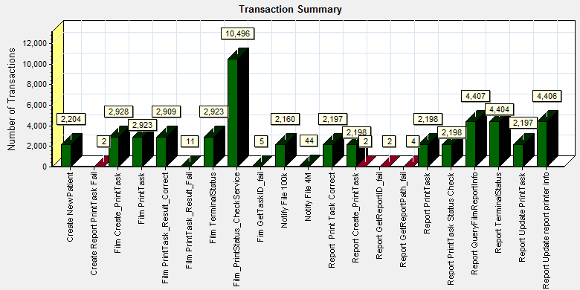

\\10.184.129.235\puma\Team\Ralf\Performance\ClouldFilm Performance\LR result\Phase5\LR_report\20180831\Report\dot_trans.gif

|  |  |  |  |  |  |  |  |  |  |
| --- | --- | --- | --- | --- | --- | --- | --- | --- | --- |
| |  |  |  | | --- | --- | --- | | **Color** | **Scale** | **Measurement** | |  | 1 | Pass | |  | 1 | Fail | |
|  |
|  |
| |  | | --- | | **Description:**Displays the number of transactions that passed, failed, stopped, or ended with errors. | |

|  |
| --- |
|  |
|  |
|  |
|  |
|  |
|  |

We can see that there are 10 transactions failed during the testing works.

### Transaction response time result of PS

We can get the transaction response time information from the figure as follow:

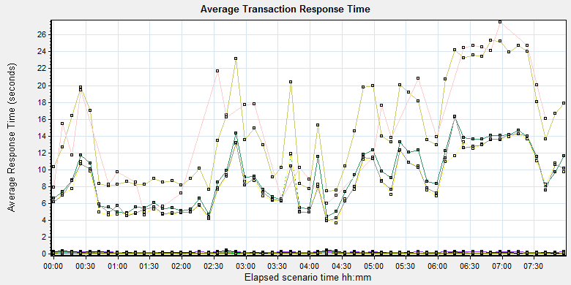

|  |  |  |  |  |  |  |  |
| --- | --- | --- | --- | --- | --- | --- | --- |
| Color | Scale | Measurement | Graph's Minimum | Graph's Average | Graph's Maximum | Graph's Median | Graph's Std. Deviation |
|  | 1 | Create New Patient | 0.162 | 0.216 | 0.346 | 0.217 | 0.038 |
|  | 1 | Film Create\_PrintTask | 4.419 | 9.24 | 16.204 | 9.053 | 3.348 |
|  | 1 | Film PrintTask | 0.06 | 0.115 | 0.241 | 0.106 | 0.041 |
|  | 1 | Film PrintTask\_Result\_Correct | 0 | 0 | 0.001 | 0 | 0 |
|  | 1 | Film PrintTask\_Result\_Fail | 0 | 0 | 0 | 0 | 0 |
|  | 1 | Film TerminalStatus | 0.039 | 0.08 | 0.282 | 0.067 | 0.038 |
|  | 1 | Film\_PrintStatus\_CheckService | 0.039 | 0.074 | 0.154 | 0.065 | 0.028 |
|  | 1 | Fim GetTaskID\_fail | 0 | 0 | 0 | 0 | 0 |
|  | 1 | Notify File 100k | 7.481 | 14.879 | 25.303 | 13.582 | 5.822 |
|  | 1 | Notify File 4M | 4.634 | 14.543 | 27.509 | 13.868 | 6.889 |
|  | 1 | Report Print Task Correct | 0 | 0 | 0 | 0 | 0 |
|  | 1 | Report Create\_PrintTask | 3.678 | 8.416 | 14.216 | 7.735 | 3.179 |
|  | 1 | Report PrintTask | 0.065 | 0.132 | 0.304 | 0.113 | 0.055 |
|  | 1 | Report PrintTask Status Check | 0.035 | 0.079 | 0.281 | 0.066 | 0.042 |
|  | 1 | Report QueryFilmReportInfo | 3.88 | 8.599 | 16.295 | 7.986 | 3.265 |
|  | 1 | Report TerminalStatus | 0.037 | 0.073 | 0.172 | 0.061 | 0.034 |
|  | 1 | Report Update PrintTask | 0.089 | 0.161 | 0.405 | 0.134 | 0.073 |
|  | 1 | Report Update report printer info | 0.038 | 0.073 | 0.181 | 0.065 | 0.028 |

Transaction response time

This figure information shows all transaction response time. We can analysis that some transaction`s response time are more than 3 seconds. The performance of the transaction is not well.

## Test result of Web service

### Test result of web transactions

After the performance testing works, the transactions result of we module as follow:

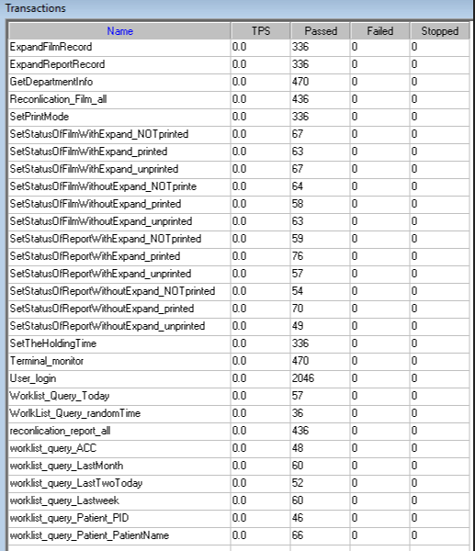

Follow the figure, we can see that there are no transactions failed.

### Test Statistic Report of Web

|  |  |  |  |  |  |  |  |  |  |  |  |  |  |  |  |  |  |  |  |  |  |  |  |  |  |  |  |  |  |  |  |  |  |  |  |  |  |  |  |  |  |  |  |  |  |  |  |  |  |  |  |  |  |
| --- | --- | --- | --- | --- | --- | --- | --- | --- | --- | --- | --- | --- | --- | --- | --- | --- | --- | --- | --- | --- | --- | --- | --- | --- | --- | --- | --- | --- | --- | --- | --- | --- | --- | --- | --- | --- | --- | --- | --- | --- | --- | --- | --- | --- | --- | --- | --- | --- | --- | --- | --- | --- | --- |
| |  |  | | --- | --- | | Analysis Summary | Period: 06/09/2018 19:15:39 - 07/09/2018 03:18:29 |  |  |  | | --- | --- | | **Scenario Name:** | D:\Performance\ScenarioPUMA\_Reliability\_171.lrs | | **Results in Session:** | c:\Users\administrator\appdata\local\temp\res1252\res1252.lrr | | **Duration:** | 8 hours, 2 minutes and 50 seconds. |  |  | | --- | | Statistics Summary |  |  |  |  | | --- | --- | --- | | [**Maximum Running Vusers:**](file:///\\10.184.129.235\puma\Team\Ralf\Performance\ClouldFilm%20Performance\LR%20result\Phase9\Web_20190907_1\VuserStateGraph) |  | 5 | | [**Total Throughput (bytes):**](file:///\\10.184.129.235\puma\Team\Ralf\Performance\ClouldFilm%20Performance\LR%20result\Phase9\Web_20190907_1\Throughput) | [Show SLA Results](slarules:total_throughput) | 734,291,697 | |  |  |  | |  |  |  | | [**Average Throughput (bytes/second):**](file:///\\10.184.129.235\puma\Team\Ralf\Performance\ClouldFilm%20Performance\LR%20result\Phase9\Web_20190907_1\Throughput) | [Show SLA Results](slarules:average_throughput) | 25,346 | |  |  |  | |  |  |  | | [**Total Hits:**](file:///\\10.184.129.235\puma\Team\Ralf\Performance\ClouldFilm%20Performance\LR%20result\Phase9\Web_20190907_1\HitsperSecond) | [Show SLA Results](slarules:total_hits) | 48,259 | |  |  |  | |  |  |  | | [**Average Hits per Second:**](file:///\\10.184.129.235\puma\Team\Ralf\Performance\ClouldFilm%20Performance\LR%20result\Phase9\Web_20190907_1\HitsperSecond) | [Show SLA Results](slarules:average_hits) | 1.666 | [**View HTTP Responses Summary**](file:///\\10.184.129.235\puma\Team\Ralf\Performance\ClouldFilm%20Performance\LR%20result\Phase9\Web_20190907_1\Web_20190907_1.html#1) | |  |  |  |  | |  |  |  |  |  |  | | --- | |  | |  |
|  |  |

|  |
| --- |
| Transaction Summary |

|  |  |  |  |  |
| --- | --- | --- | --- | --- |
| [**Transactions:**](file:///\\10.184.129.235\puma\Team\Ralf\Performance\ClouldFilm%20Performance\LR%20result\Phase9\Web_20190907_1\TransactionSummary) | Total Passed: 6,374 | Total Failed: 0 | Total Stopped: 0 | [**Average Response Time**](file:///\\10.184.129.235\puma\Team\Ralf\Performance\ClouldFilm%20Performance\LR%20result\Phase9\Web_20190907_1\ResponseTime) |

|  |  |  |  |
| --- | --- | --- | --- |
|  | **Pass** | **Fail** | **Stop** |
| [Total](file:///\\10.184.129.235\puma\Team\Ralf\Performance\ClouldFilm%20Performance\LR%20result\Phase9\Web_20190907_1\TransactionSummary0013(Total)0013) | 6,374 | 0 | 0 |

|  |  |  |  |  |  |  |  |  |
| --- | --- | --- | --- | --- | --- | --- | --- | --- |
| **Transaction Name** | **Minimum** | **Average** | **Maximum** | **Std. Deviation** | **90 Percent** | **Pass** | **Fail** | **Stop** |
| [ExpandFilmRecord](file:///\\10.184.129.235\puma\Team\Ralf\Performance\ClouldFilm%20Performance\LR%20result\Phase9\Web_20190907_1\ResponseTime0000(ExpandFilmRecord)0000) | 0.093 | 0.229 | 4.403 | 0.406 | 0.304 | 336 | 0 | 0 |
| [ExpandReportRecord](file:///\\10.184.129.235\puma\Team\Ralf\Performance\ClouldFilm%20Performance\LR%20result\Phase9\Web_20190907_1\ResponseTime0000(ExpandReportRecord)0000) | 0.006 | 0.015 | 0.138 | 0.015 | 0.024 | 336 | 0 | 0 |
| [GetDepartmentInfo](file:///\\10.184.129.235\puma\Team\Ralf\Performance\ClouldFilm%20Performance\LR%20result\Phase9\Web_20190907_1\ResponseTime0000(GetDepartmentInfo)0000) | 0.005 | 0.011 | 0.134 | 0.01 | 0.02 | 470 | 0 | 0 |
| [Reconlication\_Film\_all](file:///\\10.184.129.235\puma\Team\Ralf\Performance\ClouldFilm%20Performance\LR%20result\Phase9\Web_20190907_1\ResponseTime0000(Reconlication_Film_all)0000) | 0.711 | 1.711 | 5.867 | 0.746 | 2.664 | 436 | 0 | 0 |
| [reconlication\_report\_all](file:///\\10.184.129.235\puma\Team\Ralf\Performance\ClouldFilm%20Performance\LR%20result\Phase9\Web_20190907_1\ResponseTime0000(reconlication_report_all)0000) | 0.023 | 0.132 | 10.88 | 0.53 | 0.224 | 436 | 0 | 0 |
| [SetPrintMode](file:///\\10.184.129.235\puma\Team\Ralf\Performance\ClouldFilm%20Performance\LR%20result\Phase9\Web_20190907_1\ResponseTime0000(SetPrintMode)0000) | 0.02 | 0.579 | 30.685 | 3.659 | 0.292 | 336 | 0 | 0 |
| [SetStatusOfFilmWithExpand\_NOTprinted](file:///\\10.184.129.235\puma\Team\Ralf\Performance\ClouldFilm%20Performance\LR%20result\Phase9\Web_20190907_1\ResponseTime0000(SetStatusOfFilmWithExpand_NOTprinted)0000) | 0.141 | 0.736 | 30.646 | 3.688 | 0.449 | 67 | 0 | 0 |
| [SetStatusOfFilmWithExpand\_printed](file:///\\10.184.129.235\puma\Team\Ralf\Performance\ClouldFilm%20Performance\LR%20result\Phase9\Web_20190907_1\ResponseTime0000(SetStatusOfFilmWithExpand_printed)0000) | 0.127 | 0.295 | 1.716 | 0.21 | 0.452 | 63 | 0 | 0 |
| [SetStatusOfFilmWithExpand\_unprinted](file:///\\10.184.129.235\puma\Team\Ralf\Performance\ClouldFilm%20Performance\LR%20result\Phase9\Web_20190907_1\ResponseTime0000(SetStatusOfFilmWithExpand_unprinted)0000) | 0.118 | 1.244 | 30.798 | 5.158 | 0.608 | 67 | 0 | 0 |
| [SetStatusOfFilmWithoutExpand\_NOTprinte](file:///\\10.184.129.235\puma\Team\Ralf\Performance\ClouldFilm%20Performance\LR%20result\Phase9\Web_20190907_1\ResponseTime0000(SetStatusOfFilmWithoutExpand_NOTprinte)0000) | 0.029 | 1.109 | 30.591 | 5.282 | 0.454 | 64 | 0 | 0 |
| [SetStatusOfFilmWithoutExpand\_printed](file:///\\10.184.129.235\puma\Team\Ralf\Performance\ClouldFilm%20Performance\LR%20result\Phase9\Web_20190907_1\ResponseTime0000(SetStatusOfFilmWithoutExpand_printed)0000) | 0.046 | 0.179 | 1.337 | 0.215 | 0.38 | 58 | 0 | 0 |
| [SetStatusOfFilmWithoutExpand\_unprinted](file:///\\10.184.129.235\puma\Team\Ralf\Performance\ClouldFilm%20Performance\LR%20result\Phase9\Web_20190907_1\ResponseTime0000(SetStatusOfFilmWithoutExpand_unprinted)0000) | 0.026 | 0.811 | 38.936 | 4.846 | 0.414 | 63 | 0 | 0 |
| [SetStatusOfReportWithExpand\_NOTprinted](file:///\\10.184.129.235\puma\Team\Ralf\Performance\ClouldFilm%20Performance\LR%20result\Phase9\Web_20190907_1\ResponseTime0000(SetStatusOfReportWithExpand_NOTprinted)0000) | 0.031 | 0.678 | 30.768 | 3.954 | 0.406 | 59 | 0 | 0 |
| [SetStatusOfReportWithExpand\_printed](file:///\\10.184.129.235\puma\Team\Ralf\Performance\ClouldFilm%20Performance\LR%20result\Phase9\Web_20190907_1\ResponseTime0000(SetStatusOfReportWithExpand_printed)0000) | 0.03 | 1.351 | 30.704 | 5.882 | 0.479 | 76 | 0 | 0 |
| [SetStatusOfReportWithExpand\_unprinted](file:///\\10.184.129.235\puma\Team\Ralf\Performance\ClouldFilm%20Performance\LR%20result\Phase9\Web_20190907_1\ResponseTime0000(SetStatusOfReportWithExpand_unprinted)0000) | 0.037 | 1.24 | 30.763 | 5.594 | 0.536 | 57 | 0 | 0 |
| [SetStatusOfReportWithoutExpand\_NOTprinted](file:///\\10.184.129.235\puma\Team\Ralf\Performance\ClouldFilm%20Performance\LR%20result\Phase9\Web_20190907_1\ResponseTime0000(SetStatusOfReportWithoutExpand_NOTprinted)0000) | 0.031 | 0.169 | 1.892 | 0.26 | 0.312 | 54 | 0 | 0 |
| [SetStatusOfReportWithoutExpand\_printed](file:///\\10.184.129.235\puma\Team\Ralf\Performance\ClouldFilm%20Performance\LR%20result\Phase9\Web_20190907_1\ResponseTime0000(SetStatusOfReportWithoutExpand_printed)0000) | 0.023 | 0.617 | 30.263 | 3.587 | 0.442 | 70 | 0 | 0 |
| [SetStatusOfReportWithoutExpand\_unprinted](file:///\\10.184.129.235\puma\Team\Ralf\Performance\ClouldFilm%20Performance\LR%20result\Phase9\Web_20190907_1\ResponseTime0000(SetStatusOfReportWithoutExpand_unprinted)0000) | 0.03 | 0.162 | 0.847 | 0.161 | 0.382 | 49 | 0 | 0 |
| [SetTheHoldingTime](file:///\\10.184.129.235\puma\Team\Ralf\Performance\ClouldFilm%20Performance\LR%20result\Phase9\Web_20190907_1\ResponseTime0000(SetTheHoldingTime)0000) | 0.016 | 0.598 | 30.578 | 3.822 | 0.219 | 336 | 0 | 0 |
| [Terminal\_monitor](file:///\\10.184.129.235\puma\Team\Ralf\Performance\ClouldFilm%20Performance\LR%20result\Phase9\Web_20190907_1\ResponseTime0000(Terminal_monitor)0000) | 0.117 | 0.229 | 2.664 | 0.184 | 0.358 | 470 | 0 | 0 |
| [User\_login](file:///\\10.184.129.235\puma\Team\Ralf\Performance\ClouldFilm%20Performance\LR%20result\Phase9\Web_20190907_1\ResponseTime0000(User_login)0000) | 0.186 | 0.427 | 10.938 | 0.359 | 0.66 | 2,046 | 0 | 0 |
| [worklist\_query\_ACC](file:///\\10.184.129.235\puma\Team\Ralf\Performance\ClouldFilm%20Performance\LR%20result\Phase9\Web_20190907_1\ResponseTime0000(worklist_query_ACC)0000) | 0.012 | 0.023 | 0.082 | 0.016 | 0.035 | 48 | 0 | 0 |
| [worklist\_query\_LastMonth](file:///\\10.184.129.235\puma\Team\Ralf\Performance\ClouldFilm%20Performance\LR%20result\Phase9\Web_20190907_1\ResponseTime0000(worklist_query_LastMonth)0000) | 0.132 | 0.238 | 0.44 | 0.074 | 0.334 | 60 | 0 | 0 |
| [worklist\_query\_LastTwoToday](file:///\\10.184.129.235\puma\Team\Ralf\Performance\ClouldFilm%20Performance\LR%20result\Phase9\Web_20190907_1\ResponseTime0000(worklist_query_LastTwoToday)0000) | 0.105 | 0.169 | 0.303 | 0.044 | 0.227 | 52 | 0 | 0 |
| [worklist\_query\_Lastweek](file:///\\10.184.129.235\puma\Team\Ralf\Performance\ClouldFilm%20Performance\LR%20result\Phase9\Web_20190907_1\ResponseTime0000(worklist_query_Lastweek)0000) | 0.134 | 0.246 | 0.492 | 0.084 | 0.35 | 60 | 0 | 0 |
| [worklist\_query\_Patient\_PatientName](file:///\\10.184.129.235\puma\Team\Ralf\Performance\ClouldFilm%20Performance\LR%20result\Phase9\Web_20190907_1\ResponseTime0000(worklist_query_Patient_PatientName)0000) | 0.013 | 0.042 | 0.462 | 0.064 | 0.072 | 66 | 0 | 0 |
| [worklist\_query\_Patient\_PID](file:///\\10.184.129.235\puma\Team\Ralf\Performance\ClouldFilm%20Performance\LR%20result\Phase9\Web_20190907_1\ResponseTime0000(worklist_query_Patient_PID)0000) | 0.014 | 0.035 | 0.237 | 0.036 | 0.072 | 46 | 0 | 0 |
| [Worklist\_Query\_Today](file:///\\10.184.129.235\puma\Team\Ralf\Performance\ClouldFilm%20Performance\LR%20result\Phase9\Web_20190907_1\ResponseTime0000(Worklist_Query_Today)0000) | 0.026 | 0.062 | 0.258 | 0.041 | 0.091 | 57 | 0 | 0 |
| [WorlkList\_Query\_randomTime](file:///\\10.184.129.235\puma\Team\Ralf\Performance\ClouldFilm%20Performance\LR%20result\Phase9\Web_20190907_1\ResponseTime0000(WorlkList_Query_randomTime)0000) | 0.148 | 0.29 | 0.845 | 0.132 | 0.374 | 36 | 0 | 0 |

|  |  |  |  |  |  |  |
| --- | --- | --- | --- | --- | --- | --- |
| **Service Level Agreement Legend:** | \\10.184.129.235\puma\Team\Ralf\Performance\ClouldFilm Performance\LR result\Phase9\Web_20190907_1\led_ok.gif | Pass | \\10.184.129.235\puma\Team\Ralf\Performance\ClouldFilm Performance\LR result\Phase9\Web_20190907_1\led_error.gif | Fail | \\10.184.129.235\puma\Team\Ralf\Performance\ClouldFilm Performance\LR result\Phase9\Web_20190907_1\led_no_data.gif | No Data |

|  |
| --- |
| HTTP Responses Summary |

|  |  |  |
| --- | --- | --- |
| **HTTP Responses** | **Total** | **Per second** |
| [HTTP\_200](file:///\\10.184.129.235\puma\Team\Ralf\Performance\ClouldFilm%20Performance\LR%20result\Phase9\Web_20190907_1\HttpReturnCodes0001(HTTP_200)0001) | 46,213 | 1.595 |
| [HTTP\_302](file:///\\10.184.129.235\puma\Team\Ralf\Performance\ClouldFilm%20Performance\LR%20result\Phase9\Web_20190907_1\HttpReturnCodes0001(HTTP_302)0001) | 2,046 | 0.071 |

Follow the summary report, we can see there are no transactions failed.

### Transaction summary result of Web

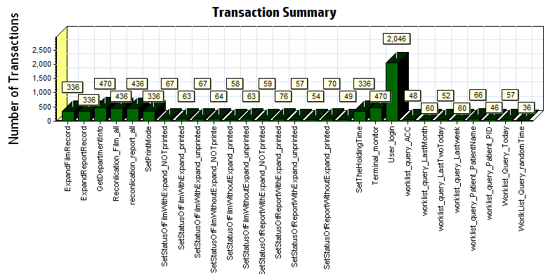

|  |  |  |  |  |  |  |
| --- | --- | --- | --- | --- | --- | --- |
| |  |  |  | | --- | --- | --- | | **Color** | **Scale** | **Measurement** | |  | **1** | **Pass** | |
|  |
|  |
| C:\Users\19007296_local\Desktop\Web_20180831_1\Report\dot_trans.gif |
|  |
|  |
|  |
|  |
|  |
|  |
|  |
|  |
|  |
|  |
|  |
|  |
|  |

We can see that there are no transactions failed during the testing works.

### Transaction response time result of Web

We can get the transaction response time information from the figure as follow:

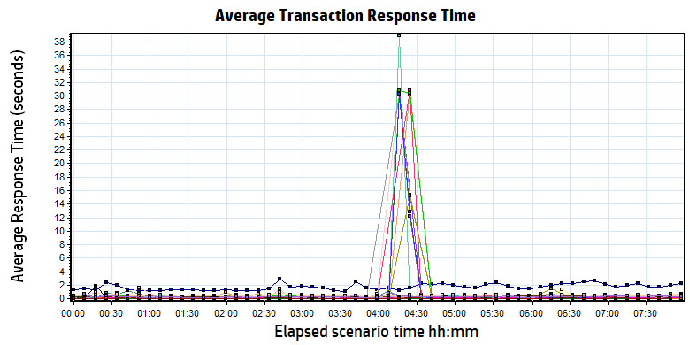

|  |  |  |  |  |  |  |
| --- | --- | --- | --- | --- | --- | --- |
| **Color** | **Scale** | **Measurement** | **Minimum** | **Average** | **Maximum** | **Std. Deviation** |
|  | 1 | ExpandFilmRecord | 0.093 | 0.229 | 4.403 | 0.406 |
|  | 1 | ExpandReportRecord | 0.006 | 0.015 | 0.138 | 0.015 |
|  | 1 | GetDepartmentInfo | 0.005 | 0.011 | 0.134 | 0.010 |
|  | 1 | Reconlication\_Film\_all | 0.711 | 1.711 | 5.867 | 0.746 |
|  | 1 | reconlication\_report\_all | 0.023 | 0.132 | 10.880 | 0.530 |
|  | 1 | SetPrintMode | 0.020 | 0.579 | 30.685 | 3.659 |
|  | 1 | SetStatusOfFilmWithExpand\_NOTprinted | 0.141 | 0.736 | 30.646 | 3.688 |
|  | 1 | SetStatusOfFilmWithExpand\_printed | 0.127 | 0.295 | 1.716 | 0.210 |
|  | 1 | SetStatusOfFilmWithExpand\_unprinted | 0.118 | 1.244 | 30.798 | 5.158 |
|  | 1 | SetStatusOfFilmWithoutExpand\_NOTprinte | 0.029 | 1.109 | 30.591 | 5.282 |
|  | 1 | SetStatusOfFilmWithoutExpand\_printed | 0.046 | 0.179 | 1.337 | 0.215 |
|  | 1 | SetStatusOfFilmWithoutExpand\_unprinted | 0.026 | 0.811 | 38.936 | 4.846 |
|  | 1 | SetStatusOfReportWithExpand\_NOTprinted | 0.031 | 0.678 | 30.768 | 3.954 |
|  | 1 | SetStatusOfReportWithExpand\_printed | 0.030 | 1.351 | 30.704 | 5.882 |
|  | 1 | SetStatusOfReportWithExpand\_unprinted | 0.037 | 1.240 | 30.763 | 5.594 |
|  | 1 | SetStatusOfReportWithoutExpand\_NOTprinted | 0.031 | 0.169 | 1.892 | 0.260 |
|  | 1 | SetStatusOfReportWithoutExpand\_printed | 0.023 | 0.617 | 30.263 | 3.587 |
|  | 1 | SetStatusOfReportWithoutExpand\_unprinted | 0.030 | 0.162 | 0.847 | 0.161 |
|  | 1 | SetTheHoldingTime | 0.016 | 0.598 | 30.578 | 3.822 |
|  | 1 | Terminal\_monitor | 0.117 | 0.229 | 2.664 | 0.184 |
|  | 1 | User\_login | 0.186 | 0.427 | 10.938 | 0.359 |
|  | 1 | worklist\_query\_ACC | 0.012 | 0.023 | 0.082 | 0.016 |
|  | 1 | worklist\_query\_LastMonth | 0.132 | 0.238 | 0.440 | 0.074 |
|  | 1 | worklist\_query\_LastTwoToday | 0.105 | 0.169 | 0.303 | 0.044 |
|  | 1 | worklist\_query\_Lastweek | 0.134 | 0.246 | 0.492 | 0.084 |
|  | 1 | worklist\_query\_Patient\_PatientName | 0.013 | 0.042 | 0.462 | 0.064 |
|  | 1 | worklist\_query\_Patient\_PID | 0.014 | 0.035 | 0.237 | 0.036 |
|  | 1 | Worklist\_Query\_Today | 0.026 | 0.062 | 0.258 | 0.041 |
|  | 1 | WorlkList\_Query\_randomTime | 0.148 | 0.290 | 0.845 | 0.132 |

|  |
| --- |
|  |
|  |
|  |

Transaction response time

Follow the figure: we can see that the transaction average response time is less than 2 seconds. Some transaction works not smoothly with short time. It can accepted by design.

|  |
| --- |
|  |
|  |
|  |
|  |
|  |

|  |
| --- |
|  |
|  |

## Performance bottleneck analysis

### Hardware usage analysis

During the testing work, we use the test tool to monitor the server hardware usage include the CPU, Memory, hard disk and etc.

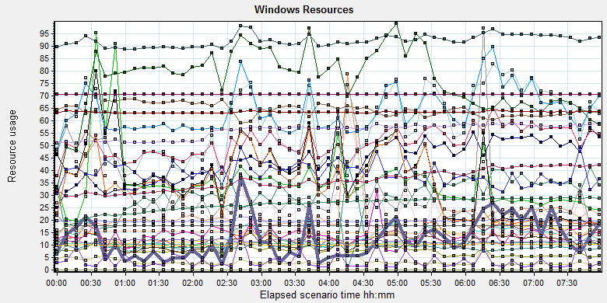

|  |  |  |  |  |  |  |  |  |  |  |  |  |  |  |  |  |  |  |  |  |  |  |  |  |  |  |  |  |  |  |  |  |  |  |  |  |  |  |  |  |  |  |  |  |  |  |  |  |  |  |  |  |  |  |  |  |  |  |  |  |  |  |  |  |  |  |  |  |  |  |  |  |  |  |  |  |  |  |  |  |  |  |  |  |  |  |  |  |  |  |  |  |  |  |  |  |  |  |  |  |  |  |  |  |  |  |  |  |  |  |  |  |  |  |  |  |  |  |  |  |  |  |  |  |  |  |  |  |  |  |  |  |  |  |  |  |  |  |  |  |  |  |  |  |  |  |  |  |  |  |  |  |  |  |  |  |  |  |  |  |  |  |  |  |  |  |  |  |  |  |  |  |  |  |  |  |  |  |  |  |  |  |  |  |  |  |  |  |  |  |  |  |  |  |  |  |  |  |  |  |  |  |  |  |  |  |  |  |  |  |  |  |  |  |  |  |  |  |  |  |  |  |  |  |  |  |  |  |  |  |  |  |  |  |  |  |  |  |  |  |  |  |  |  |  |  |  |  |  |  |  |  |  |  |  |  |  |  |  |  |  |  |  |  |  |  |  |  |  |  |  |  |  |  |  |  |  |  |  |  |
| --- | --- | --- | --- | --- | --- | --- | --- | --- | --- | --- | --- | --- | --- | --- | --- | --- | --- | --- | --- | --- | --- | --- | --- | --- | --- | --- | --- | --- | --- | --- | --- | --- | --- | --- | --- | --- | --- | --- | --- | --- | --- | --- | --- | --- | --- | --- | --- | --- | --- | --- | --- | --- | --- | --- | --- | --- | --- | --- | --- | --- | --- | --- | --- | --- | --- | --- | --- | --- | --- | --- | --- | --- | --- | --- | --- | --- | --- | --- | --- | --- | --- | --- | --- | --- | --- | --- | --- | --- | --- | --- | --- | --- | --- | --- | --- | --- | --- | --- | --- | --- | --- | --- | --- | --- | --- | --- | --- | --- | --- | --- | --- | --- | --- | --- | --- | --- | --- | --- | --- | --- | --- | --- | --- | --- | --- | --- | --- | --- | --- | --- | --- | --- | --- | --- | --- | --- | --- | --- | --- | --- | --- | --- | --- | --- | --- | --- | --- | --- | --- | --- | --- | --- | --- | --- | --- | --- | --- | --- | --- | --- | --- | --- | --- | --- | --- | --- | --- | --- | --- | --- | --- | --- | --- | --- | --- | --- | --- | --- | --- | --- | --- | --- | --- | --- | --- | --- | --- | --- | --- | --- | --- | --- | --- | --- | --- | --- | --- | --- | --- | --- | --- | --- | --- | --- | --- | --- | --- | --- | --- | --- | --- | --- | --- | --- | --- | --- | --- | --- | --- | --- | --- | --- | --- | --- | --- | --- | --- | --- | --- | --- | --- | --- | --- | --- | --- | --- | --- | --- | --- | --- | --- | --- | --- | --- | --- | --- | --- | --- | --- | --- | --- | --- | --- | --- | --- | --- | --- | --- | --- | --- | --- | --- | --- | --- | --- | --- | --- | --- | --- | --- | --- | --- | --- | --- | --- | --- | --- | --- | --- | --- |
| |  |  |  |  |  |  |  | | --- | --- | --- | --- | --- | --- | --- | | **Color** | **Scale** | **Measurement** | **Minimum** | **Average** | **Maximum** | **Std. Deviation** | |  | 0.01 | % Disk Time (PhysicalDisk \_Total):10.184.129.108 | 9.341 | 313.984 | 15159.438 | 411.346 | |  | 1 | % Idle Time (PhysicalDisk \_Total):10.184.129.108 | 0 | 28.966 | 94.76 | 23.871 | |  | 100 | % Interrupt Time (Processor \_Total):10.184.129.108 | 0 | 0.136 | 0.781 | 0.101 | |  | 1 | % Privileged Time (Processor \_Total):10.184.129.108 | 0.174 | 13.869 | 34.888 | 4.083 | |  | 10 | % Processor Time (Process CloudDataUploadService):10.184.129.108 | 0 | 4.335 | 29.688 | 4.28 | |  | 1 | % Processor Time (Processor \_Total):10.184.129.108 | 0 | 59.137 | 100 | 19.951 | |  | 0.01 | Available MBytes (Memory):10.184.129.108 | 5124 | 6440.77 | 7118 | 298.982 | |  | 0.0001 | Avg. Disk Bytes/Transfer (PhysicalDisk \_Total):10.184.129.108 | 4096 | 218127.435 | 3953408 | 188090.875 | |  | 1 | Avg. Disk Queue Length (PhysicalDisk \_Total):10.184.129.108 | 0.093 | 3.14 | 151.594 | 4.113 | |  | 10 | Avg. Disk Write Queue Length (PhysicalDisk \_Total):10.184.129.108 | 0.076 | 2.559 | 31.481 | 2.608 | |  | 0.001 | Bytes Total/sec (Server):10.184.129.108 | 4406.196 | 19706.738 | 106621.129 | 1025.363 | |  | 1E-07 | Cache Bytes (Memory):10.184.129.108 | 135368704 | 261525473.792 | 307437568 | 31025812.484 | |  | 1E-09 | Committed Bytes (Memory):10.184.129.108 | 9948643328 | 10650992330.683 | 12094402560 | 336324495.895 | |  | 0.001 | Context Switches/sec (System):10.184.129.108 | 3081.777 | 51241.292 | 219320.965 | 24986.912 | |  | 10 | Current Disk Queue Length (PhysicalDisk \_Total):10.184.129.108 | 0 | 3.161 | 179 | 5.3 | |  | 1E-05 | Disk Read Bytes/sec (PhysicalDisk \_Total):10.184.129.108 | 0 | 3539449.49 | 67055735.899 | 4388606.104 | |  | 1 | Disk Reads/sec (PhysicalDisk \_Total):10.184.129.108 | 0 | 37.339 | 1789.873 | 48.429 | |  | 0.1 | Disk Transfers/sec (PhysicalDisk \_Total):10.184.129.108 | 5.646 | 76.182 | 1808.805 | 52.423 | |  | 1E-06 | Disk Write Bytes/sec (PhysicalDisk \_Total):10.184.129.108 | 27196.151 | 10009152.381 | 99784140.612 | 7824612.902 | |  | 1 | Disk Writes/sec (PhysicalDisk \_Total):10.184.129.108 | 3.987 | 38.843 | 237.154 | 20.39 | |  | 0.001 | File Data Operations/sec (System):10.184.129.108 | 489.559 | 13201.064 | 60207.388 | 7995.558 | |  | 1E-05 | Free Megabytes (LogicalDisk \_Total):10.184.129.108 | 1414749 | 1499036.525 | 1580900 | 48200.81 | |  | 0.01 | Interrupts/sec (Processor \_Total):10.184.129.108 | 890.793 | 6396.063 | 33800.258 | 3700.732 | |  | 0.0001 | Page Faults/sec (Memory):10.184.129.108 | 205.586 | 107895.628 | 350167.222 | 55358.696 | |  | 0.1 | Page Faults/sec (Process CloudDataUploadService):10.184.129.108 | 0 | 138.417 | 5537.028 | 402.997 | |  | 1E-06 | Page File Bytes (Process CloudDataUploadService):10.184.129.108 | 49848320 | 55851310.722 | 100577280 | 3137051.282 | |  | 1 | Page Reads/sec (Memory):10.184.129.108 | 0 | 33.455 | 700.829 | 40.265 | |  | 0.1 | Pages/sec (Memory):10.184.129.108 | 0 | 763.438 | 9527.822 | 767.329 | |  | 1E-06 | Pool Nonpaged Bytes (Memory):10.184.129.108 | 61825024 | 63408175.014 | 65306624 | 354064.95 | |  | 1E-05 | Pool Nonpaged Bytes (Server):10.184.129.108 | 966913 | 1167958.162 | 1356673 | 67192.186 | |  | 1E-07 | Pool Paged Bytes (Memory):10.184.129.108 | 176107520 | 179094477.901 | 237387776 | 5604907.806 | |  | 0.001 | Pool Paged Bytes (Server):10.184.129.108 | 70613 | 70613.106 | 70869 | 5.217 | |  | 1 | Pool Paged Failures (Server):10.184.129.108 | 0 | 0 | 0 | 0 | |  | 1E-08 | Private Bytes (Process \_Total):10.184.129.108 | 8620609536 | 9210163589.305 | 10400735232 | 267436629.165 | |  | 10 | Processor Queue Length (System):10.184.129.108 | 0 | 1.264 | 53 | 4.119 | |  | 1 | Split IO/Sec (PhysicalDisk \_Total):10.184.129.108 | 0 | 3.571 | 223.204 | 14.559 | |  | 1E-07 | System Cache Resident Bytes (Memory):10.184.129.108 | 135368704 | 261525145.754 | 307437568 | 31025719.03 | |  | 0.01 | Threads (Objects):10.184.129.108 | 2700 | 3590.85 | 4407 | 413.618 | |  | 1E-09 | Working Set (Process \_Total):10.184.129.108 | 9248587776 | 10079089141.629 | 11561959424 | 345809695.387 | |
|  |
|  |
| \\10.184.129.235\puma\Team\Ralf\Performance\ClouldFilm Performance\LR result\Phase9\20180907_1\Report\dot_trans.gif |
|  |
| **Description:**Displays a summary of the System Resources usage for each Windows based host. |
|  |

### SQL Server resource usage analysis

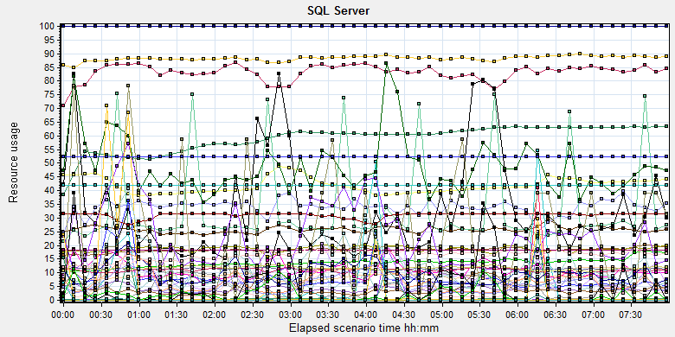

|  |  |  |  |  |  |  |
| --- | --- | --- | --- | --- | --- | --- |
| **Color** | **Scale** | **Measurement** | **Minimum** | **Average** | **Maximum** | **Std. Deviation** |
|  | 0.01 | Average Latch Wait Time (ms) (MSSQL$GCPACSWS|Latches):10.184.129.108 | 0 | 67.152 | 23046.8 | 529.065 |
|  | 1 | Buffer cache hit ratio (MSSQL$GCPACSWS|Buffer Manager):10.184.129.108 | 94.36 | 99.991 | 100 | 0.079 |
|  | 1 | Cache Hit Ratio (MSSQL$GCPACSWS|Catalog Metadata \_Total):10.184.129.108 | 37.773 | 58.986 | 63.4 | 5.024 |
|  | 1 | Cache Hit Ratio (MSSQL$GCPACSWS|Cursor Manager by Type \_Total):10.184.129.108 | 62.992 | 83.15 | 90.625 | 3.726 |
|  | 1 | Cache Hit Ratio (MSSQL$GCPACSWS|Plan Cache \_Total):10.184.129.108 | 73.216 | 88.277 | 97.226 | 3.825 |
|  | 1 | Checkpoint pages/sec (MSSQL$GCPACSWS|Buffer Manager):10.184.129.108 | 0 | 6.593 | 166.756 | 16.807 |
|  | 0.01 | Connection Memory (KB) (MSSQL$GCPACSWS|Memory Manager):10.184.129.108 | 2064 | 2578.264 | 3528 | 145.308 |
|  | 0.1 | Connection Reset/sec (MSSQL$GCPACSWS|General Statistics):10.184.129.108 | 66.814 | 183.228 | 697.04 | 79.101 |
|  | 1 | Current latch waits (MSOLAP$GCPACSWS|Locks):10.184.129.108 | 0 | 0 | 0 | 0 |
|  | 1 | Cursor flushes (MSSQL$GCPACSWS|Cursor Manager Total):10.184.129.108 | 0 | 0 | 0 | 0 |
|  | 0.0001 | Cursor memory usage (MSSQL$GCPACSWS|Cursor Manager by Type \_Total):10.184.129.108 | 88 | 56499.951 | 212416 | 50734.922 |
|  | 10 | Cursor Requests/sec (MSSQL$GCPACSWS|Cursor Manager by Type \_Total):10.184.129.108 | 0 | 3.39 | 81.288 | 2.709 |
|  | 0.0001 | Database pages (MSSQL$GCPACSWS|Buffer Manager):10.184.129.108 | 377010 | 419577.712 | 492939 | 28470.352 |
|  | 10 | Errors/sec (MSSQL$GCPACSWS|SQL Errors \_Total):10.184.129.108 | 0 | 3.308 | 18.081 | 2.777 |
|  | 1000 | Free list stalls/sec (MSSQL$GCPACSWS|Buffer Manager):10.184.129.108 | 0 | 0.001 | 6.641 | 0.068 |
|  | 0.0001 | Free pages (MSSQL$GCPACSWS|Buffer Manager):10.184.129.108 | 55 | 47549.688 | 131619 | 37887.383 |
|  | 0.1 | Full Scans/sec (MSSQL$GCPACSWS|Access Methods):10.184.129.108 | 3.653 | 135.879 | 871.515 | 119.722 |
|  | 0.001 | Granted Workspace Memory (KB) (MSSQL$GCPACSWS|Memory Manager):10.184.129.108 | 0 | 33397.843 | 722688 | 86993.261 |
|  | 0.001 | Index Searches/sec (MSSQL$GCPACSWS|Access Methods):10.184.129.108 | 0 | 18666.25 | 61174.699 | 13634.991 |
|  | 1 | Latch waits/sec (MSOLAP$GCPACSWS|Locks):10.184.129.108 | 0 | 0 | 0 | 0 |
|  | 1 | Latch Waits/sec (MSSQL$GCPACSWS|Latches):10.184.129.108 | 0 | 8.763 | 1116.697 | 26.342 |
|  | 100 | Lazy writes/sec (MSSQL$GCPACSWS|Buffer Manager):10.184.129.108 | 0 | 0.04 | 16.612 | 0.411 |
|  | 0.001 | Lock Memory (KB) (MSSQL$GCPACSWS|Memory Manager):10.184.129.108 | 6024 | 9105.38 | 11952 | 1510.774 |
|  | 1 | Lock Timeouts (timeout > 0)/sec (MSSQL$GCPACSWS|Locks \_Total):10.184.129.108 | 0 | 0 | 0 | 0 |
|  | 10 | Lock Timeouts/sec (MSSQL$GCPACSWS|Locks \_Total):10.184.129.108 | 0 | 1.096 | 49.063 | 1.994 |
|  | 0.1 | Lock Wait Time (ms) (MSSQL$GCPACSWS|Locks \_Total):10.184.129.108 | 0 | 93.511 | 17530.362 | 422.562 |
|  | 1 | Lock waits/sec (MSOLAP$GCPACSWS|Locks):10.184.129.108 | 0 | 0 | 0 | 0 |
|  | 100 | Lock Waits/sec (MSSQL$GCPACSWS|Locks \_Total):10.184.129.108 | 0 | 0.488 | 10.241 | 0.586 |
|  | 1E-05 | Maximum Workspace Memory (KB) (MSSQL$GCPACSWS|Memory Manager):10.184.129.108 | 2522880 | 3104168.127 | 3151800 | 107423.201 |
|  | 10 | Memory Grants Outstanding (MSSQL$GCPACSWS|Memory Manager):10.184.129.108 | 0 | 0.422 | 13 | 0.794 |
|  | 1 | Memory Grants Pending (MSSQL$GCPACSWS|Memory Manager):10.184.129.108 | 0 | 0 | 0 | 0 |
|  | 1E-18 | Number of active cursor plans (MSSQL$GCPACSWS|Cursor Manager by Type \_Total):10.184.129.108 | 1.84467440737095E+19 | 1.84467440737095E+19 | 1.84467440737095E+19 | 274877906944 |
|  | 10000 | Number of Deadlocks/sec (MSSQL$GCPACSWS|Locks \_Total):10.184.129.108 | 0 | 0.002 | 0.665 | 0.027 |
|  | 1 | Number of SuperLatches (MSSQL$GCPACSWS|Latches):10.184.129.108 | 0 | 0 | 0 | 0 |
|  | 0.01 | Optimizer Memory (KB) (MSSQL$GCPACSWS|Memory Manager):10.184.129.108 | 1088 | 1143.466 | 4480 | 289.797 |
|  | 1 | Page Deallocations/sec (MSSQL$GCPACSWS|Access Methods):10.184.129.108 | 0 | 23.363 | 682.822 | 56.068 |
|  | 0.0001 | Page life expectancy (MSSQL$GCPACSWS|Buffer Manager):10.184.129.108 | 2 | 17345.611 | 4294965 | 243140.075 |
|  | 0.0001 | Page lookups/sec (MSSQL$GCPACSWS|Buffer Manager):10.184.129.108 | 0 | 109923.555 | 359205.555 | 48471.206 |
|  | 0.1 | Page reads/sec (MSSQL$GCPACSWS|Buffer Manager):10.184.129.108 | 0 | 46.823 | 7575.692 | 390.778 |
|  | 1 | Page Splits/sec (MSSQL$GCPACSWS|Access Methods):10.184.129.108 | 0 | 9.637 | 625.921 | 22.026 |
|  | 1 | Page writes/sec (MSSQL$GCPACSWS|Buffer Manager):10.184.129.108 | 0 | 12.88 | 345.39 | 28.283 |
|  | 0.001 | Reserved pages (MSSQL$GCPACSWS|Buffer Manager):10.184.129.108 | 0 | 4154.247 | 90238 | 10857.707 |
|  | 0.001 | SQL Cache Memory (KB) (MSSQL$GCPACSWS|Memory Manager):10.184.129.108 | 1936 | 6891.951 | 18584 | 3911.837 |
|  | 0.1 | SQL Compilations/sec (MSSQL$GCPACSWS|SQL Statistics):10.184.129.108 | 71.37 | 117.679 | 447.086 | 20.78 |
|  | 100 | SQL Re-Compilations/sec (MSSQL$GCPACSWS|SQL Statistics):10.184.129.108 | 0 | 0.163 | 2.323 | 0.271 |
|  | 0.0001 | Stolen pages (MSSQL$GCPACSWS|Buffer Manager):10.184.129.108 | 5256 | 57160.599 | 146847 | 32075.895 |
|  | 0.0001 | Target pages (MSSQL$GCPACSWS|Buffer Manager):10.184.129.108 | 524288 | 524288 | 524288 | 0 |
|  | 1E-05 | Target Server Memory (KB) (MSSQL$GCPACSWS|Memory Manager):10.184.129.108 | 4194304 | 4194304 | 4194304 | 0 |
|  | 1 | Tasks Started/sec (MSSQL$GCPACSWS|Broker Activation tempdb):10.184.129.108 | 0 | 0 | 0 | 0 |
|  | 1 | Temp file bytes written/sec (MSOLAP$GCPACSWS|Proc Aggregations):10.184.129.108 | 0 | 0 | 0 | 0 |
|  | 10 | Temp Tables Creation Rate (MSSQL$GCPACSWS|General Statistics):10.184.129.108 | 0 | 0.203 | 19.89 | 1.073 |
|  | 10 | Temp Tables For Destruction (MSSQL$GCPACSWS|General Statistics):10.184.129.108 | 0 | 0.452 | 65 | 3.906 |
|  | 1 | Total deadlocks detected (MSOLAP$GCPACSWS|Locks):10.184.129.108 | 0 | 0 | 0 | 0 |
|  | 0.001 | Total Latch Wait Time (ms) (MSSQL$GCPACSWS|Latches):10.184.129.108 | 0 | 470.098 | 70757.098 | 2732.233 |
|  | 0.0001 | Total pages (MSSQL$GCPACSWS|Buffer Manager):10.184.129.108 | 524288 | 524288 | 524288 | 0 |
|  | 1E-05 | Total Server Memory (KB) (MSSQL$GCPACSWS|Memory Manager):10.184.129.108 | 4194304 | 4194304 | 4194304 | 0 |

## Test Conclusion

The result of this phase testing works is not good. There are 21 test errors and 10 main workflows failed during the testing works.

Some transaction average response time is more than 3 seconds. The CPU usage is close to the performance threshold value but still can accept. Even there are some locks and latches exist in the database, but they do not block the main workflow execute operations.

Now the upload attachments operation meets the requirements. I collect the records which created time is performance start time and status end time is extend 3 hours after testing works. The detail information as follow:

|  |  |  |  |
| --- | --- | --- | --- |
| Type | Count | Size | All |
| Dicom | 3315 | 19M | 62,985M |
| Dicom Png | 3315 | 2.3M | 7,624.5M |
| Report Jpg | 1876 | 0.15M | 281.4M |
| Report PDF | 1876 | 0.12M | 225.12M |
|  |  |  | 70,756.02 MB |

The system uploaded 70.7GB data to server in 11 hours. The result meets the requirements.

During the testing works, we print 2928 films and 2197 reports. Upload 70.7GB data include dicom, dicom png, jpg report and pdf reports. The report print count does not meet requirements (more than 3000). Because the report archive and create print task transaction execute slowly.

There are some hardware issues block the performance testing works. The test environment needs to rebuild to make the test correctly and smoothly. I will continue the performance testing work on B27 with new test environment.